Foundation Technologies

Memory Monitor

Requirements Specification

Introduction 3
Problem Description 3
Users 3
Assumptions 3
Solution Overview 4
Runtime Library Component Requirements 5
Functional Requirements 5
Non-Functional Requirements 9
Host Memory Monitor Tool Requirements 10
Functional Requirements 10
Project Issues 14
Third-Party Off-the-Shelf Solutions 14
Risks, Fall-backs, and Unresolved Issues 14
Next Steps 14

Introduction

The Memory Monitor is a tool used to monitor and report information regarding the state of memory. The Memory Monitor will operate primarily outside of the target platform whose memory is being observed.

Problem Description

Problems regarding the management of memory in Radical’s games are common. These problems include memory leaks, memory fragmentation, and inefficient use of memory. To remedy these problems, software developers need information regarding the state of memory in their game. Providing developers with memory information is the problem discussed here. Problems that exist today include:

- Memory monitoring tools used by games teams are proprietary
- No way to obtain a graphical representation of the state of memory.
- Cannot determine what software component is responsible for a given memory allocation.
- Existing memory tracking systems operate primarily on the target, thus consuming target memory and processor resources.

Users

The users of the Memory Monitor will primarily be software developers and testers. They will use the tool to detect and remedy problems associated with memory management.

Assumptions

The solution presented in this document assumes the existence of a data communication path between the target platform and the host Windows operating environment.

Solution Overview

To solve the problems cited in the previous section, a new tool for monitoring memory will be developed. The tool will be made up of two components: a graphical user interface tool and a runtime library. The graphical user interface tool will operate outside of the game and will be responsible for maintaining and displaying information regarding memory. The runtime library component will operate within the game running on the target platform will be responsible for acquiring and forwarding memory information to the host tool.

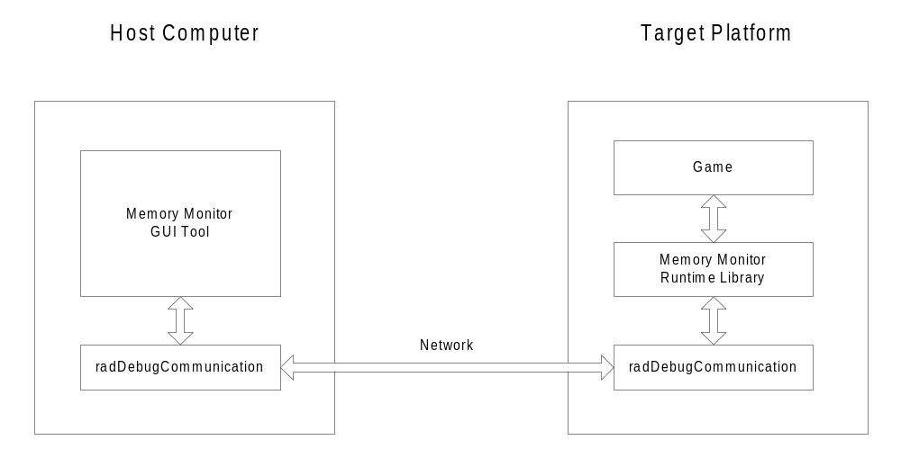

It should be noted, that the Memory Monitor will not directly solve or prevent problems associated with a game’s memory management. It is only an information tool. It is still up to the game developers to use memory effectively and without leaks.

Runtime Library Component Requirements

This section outlines the requirements for the runtime library component of the memory monitor. This is the component that is bound to the game and executes on the target. For the remainder of the document, this component will be referred to as the radMemoryMonitor

Functional Requirements

Requirement ID: 1
Description: radMemoryMonitor will provide a platform independent interface.
Rational: We do not want to burden users of this system with having to write platform specific code.

Requirement ID: 2
Description: radMemoryMonitor will be written using inline/macro functions that will vanish dependent upon the absence or presence of a preprocessor directive.
Rational: The radMemoryMonitor code is used only for development. It should be possible to remove it from a release version of the game with minimal effort.

Requirement ID: 3
Description: radMemoryMonitor will not be coupled to a particular memory management system. The services provided by radMemoryMonitor can be used by any component to report and track memory.
Rational: The system must be flexible and useful to any memory management system. If a game develops a proprietary memory manager, it still should be able to use the radMemoryMonitor services to report and track its memory usage.

Requirement ID: 4
Description: radMemoryMonitor will provide two modes of operation: Intrusive and Non-Intrusive. In intrusive mode, the current state of memory on the target will be maintained on the target. This mode must use memory on the target and thus is intrusive. Non-intrusive mode will maintain the state of the targets memory on the host. Minimal target memory will be used by radMemoryMonitor and thus is non-intrusive.
Rational: Intrusive mode will allow the user to launch the host Memory Monitor after the game has been running. It can obtain the current memory state as it is maintained on the target. Using the Non-Intrusive mode, the host Memory Monitor must be run in advance of the game. Minimal memory intrusion occurs in this mode.

Requirement ID: 5
Description: In the absence of the host GUI Memory Monitor tool running, radMemoryMonitor will operate without any ill effects to the game.
Rational: Much of the time, developers will run the game without being concerned about monitoring memory and will not run the Memory Monitor. The game must still operate correctly in this case.

Requirement ID: 6
Description: radMemoryMonitor will forward memory information asynchronously to the host. Under host control, the game can be suspended on any radMemoryMonitor service.
Rational: We want the game to run as fast as possible with minimal performance hits due to radMemoryMonitor. Some times due to communication protocol requirements or explicit user intervention, the game will be suspended. This will allow the user to look at memory without it changing.

Requirement ID: 7
Description: radMemoryMonitor will provide a mechanism whereby the client can control what memory the radMemoryMonitor uses for its internal needs.
Rational: The user should be able to control what memory is used by the radMemoryMonitor to provide minimal impact to the game. For example, on the PS2 there is a large amount of debug memory that can be used by development tools.

Requirement ID: 8
Description: radMemoryMonitor will provide services whereby the game can identify static memory sections for display in the host tool.
Rational: The host memory monitor should be capable of displaying an entire picture of the target memory. This includes such memory sections as code and static data.

Requirement ID: 9
Description: radMemoryMonitor will provide services that will allow the game to identify its stack (or stacks).
Rational: The host memory monitor should be capable of displaying information about a stack including its location and its “high water mark”.

Requirement ID: 10
Description: Services will be provided to allow the game to identify a memory space that is used for dynamic memory allocation. This memory space can be in external memory (i.e. in sound memory, IOP memory, etc).
Rational: This is needed since some games use multiple heaps and a view of each heap should be presented in the Memory Monitor tool. As memory allocations occur, they can be tagged as belonging to a particular heap.

Requirement ID: 11
Description: When a memory space is identified as being used for dynamic memory allocation, the caller can provide information regarding default alignment and size in bytes of memory used as overhead in managing this heap.
Rational: If the game is using a third party heap, it may not be able to report the address of the true memory allocations. This information can be used to display a memory picture without lots of little unaccountable holes in it.

Requirement ID: 12
Description: Services will be provided to flag allocations and de-allocations of memory.
Rational: These are the primary functions used to report allocations and de-allocations of memory to the Memory Monitor tool.

Requirement ID: 13
Description: The service used to indicate a memory allocation will require the client to provide the following information:
- Address of the memory block
- Size of the memory block
- Dynamic memory identifier (heap Id)

Optionally the client will be able to specify
  - String used to identify the memory
  - Group id that can be used to sort and display against
  - Address of the objects reference count (if reference counted)
Rational: This is the information required by the Memory Monitor to create a graphical representation of memory. The optional information can used to provide the user with additional useful information.

Requirement ID: 14
Description: radMemoryMonitor shall allow the client to specify the depth of call stack that should be sent to the host when the allocation flagging service is invoked.
Rational: This information can be used to create a call graph illustrating how a piece of memory was allocated. This feature can cause significant overhead and if not required can be disabled by setting the depth to zero.

Requirement ID: 15
Description: radMemoryMonitor shall allow the client to issue event flags. The client will be able to specify a string that will show up in the time-based view of memory.
Rational: Games can use this service to flag important events in their game. When they observe a time-based view of memory, they can correlate the state of memory at a given time with significant game events.

Requirement ID: 16
Description: radMemoryMonitor shall allow the client to suspend the game and put the host Memory Monitor into a stopped state.
Rational: This functionality is very similar to that provided by a debugger and a break instruction. A break instruction can be placed in code at some point of interest, and when program execution encounters this instruction, the debugger is invoked. As an additional point of interest, the game may want to cause the memory monitor to stop data acquisition and display the current state of memory.

Requirement ID: 17
Description: radMemoryMonitor may provide a mechanism that will allow the host Memory Monitor tool to display and edit raw memory.
Rational: This feature might be useful to find out what memory looks like. We should not spend too much effort on this functionality as we are crossing into the domain of debuggers.

Requirement ID: 18
Description: radMemoryMonitor may provide services to that allow the game to obtain course grain information about the state of memory. This will only be available if intrusive mode is used.
Rational: The game may want to display limited memory statistics itself without the need to launch the Memory Monitor tool.

Requirement ID: 19
Description: radMemoryMonitor may provide services to track references between objects. These services would be invoked whenever an addref or release operation was performed. The caller would invoke the radMemoryMonitor with the address of where the reference was being stored and the object being referenced.
Rational: This feature would provide a picture of the active object relationship in the game. It would be very useful in identifying who was holding onto stranded objects.

Non-Functional Requirements

Requirement ID: 20
Description: radMemoryMonitor will adhere to the abstract interface, reference counted, object factory paradigm employed by all Foundation Technology components.
Rational: This paradigm has proven to be very effective and is consistent with other Foundation Technologies components.

Requirement ID: 21
Description: radMemoryMonitor will adhere to interface naming conventions set forth by the Foundation Technologies group.
Rational: Consistency amongst library components greatly simplifies the client’s programming experience.

Host Memory Monitor Tool Requirements

This section outlines the requirements for the host component of the memory monitor. This is the component that runs on the host machine, decoupled from the actual game. This component will provide a graphical view of the target game’s memory. For the remainder of the document, this component will be referred to as the Memory Monitor.

Below is a rough diagram of what the memory monitor will look like. The diagram will be referred to throughout following requirements.

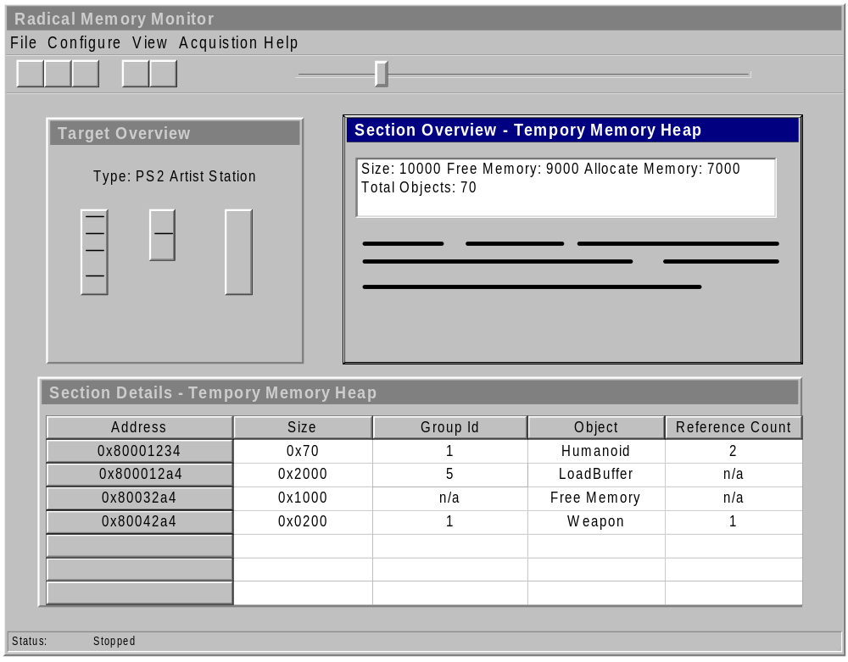

Functional Requirements

Requirement ID: 1
Description: The Memory Monitor will be a Windows application.
Rational: This is the standard development platform employed by Radical.

Requirement ID: 2
Description: The Memory Monitor can be launched once and will correctly respond to resets of the target game.
Rational: We don’t want to burden the user from having to reset his tool every time the game is reset and restarted.

Requirement ID: 3
Description: The Memory Monitor’s primary view is the Target Overview window. This window will provide a graphical representation of each memory space (i.e. main memory, sound memory, PS2IOP memory) on the target. Within each memory space, the various memory sections (code, temporary heap, stack) will be identified. Specifics of the look of this view need to be worked out.
Rational: This view provides the user a high level overview of memory on the target. It is from this view the user can “drill down” to determine more detailed information about the various sections.

Requirement ID: 4
Description: The Memory Monitor will have two modes of operation: Running and Stopped. In running mode, the Memory monitor will allow the target to run and will continue to acquire and log memory information. In stopped mode, the game will be suspended and acquisition will halt.
Rational: When the Memory Monitor is running, the user can get a high level dynamic view of memory. When the user wants to examine memory in detail, he does not want it changing. The two modes of operation facilitate this use.

Requirement ID: 5
Description: When the user right clicks on a memory section found in the target view, the user will be able to open either the section overview or section detail window.
Rational: These two views provide more information about the selected memory section.

Requirement ID: 6
Description: The section overview shall provide high-level statistics about the memory section along with a graphical representation of allocated memory in the section. This view will be continually updated when the Memory Monitor is in running mode. This view will be context sensitive to the type of memory section (stack, static data, dynamic data).
Rational: The user can use this view to find out about high-level details of a memory section. He can also observe how memory is changing in real time.

Requirement ID: 7
Description: When the user double clicks on the graphical view of memory found in the section overview window, the section detail view will be opened at the indicated memory address.
Rational: This is another mechanism for launching the memory detail window and for quickly navigating to a specific memory location.

Requirement ID: 8
Description: The section detail window will provide detailed memory information about a section. This window will be blanked out when the monitor is running.
Rational: Here is where the user can find out detailed information about allocated memory in a memory section. It would not make sense to enable this window while the memory monitor was running, as its data is very dynamic.

Requirement ID: 9
Description: When the user scrolls through the rows in the section detail window, the corresponding location will be highlighted in the section overview window.
Rational: Gives the user a better picture of what memory he is looking at.

Requirement ID: 10
Description: The section detail view will contain the address, size, name, group id and reference count of each allocated block of memory. Free memory will also be identified.
Rational: This is the information that was provided by the runtime radMemoryMonitor.

Requirement ID: 11
Description: The user will be able to sort data in the section detail window by clicking on a column heading. Default sorting will be by address.
Rational: Users may want to see the view in a different way. A typical view would be to sort by size.

Requirement ID: 12
Description: When the user selects a row in the target he can right click to either select a memory dump or call stack view of the corresponding piece of memory.
Rational: This is the most natural way to “drill down” to obtain more details.

Requirement ID: 13
Description: The memory dump window (not shown in prototype) will provide a view of raw memory. It will be a modal window. We may provide a mechanism to edit the memory.
Rational: The user may want to examine a piece of memory and potentially alter it.

Requirement ID: 14
Description: The call stack window (not shown prototype) will provide a view of the call stack associated with the particular allocation. This will be a modal window. This view will only be enabled if a symbol table has been made available to the Memory Monitor.
Rational: The user can use this view to help him identify who allocated the memory.

Requirement ID: 15
Description: The Memory Monitor shall use colour coding to highlight memory of the same group id.
Rational: This feature will provide the user with a better picture of how memory is being used.

Requirement ID: 16
Description: The Memory Monitor will have a configuration dialog. The dialog will allow the user to configure the following parameters:
- Symbol file location
- Colour code to group id mapping
- Logging duration
- Memory overhead filters
- Target Selection
Rational: This is information that the user will want to control.

Requirement ID: 17
Description: The Memory Monitor will log memory operations. Once the memory monitor is in stopped mode, the user will be able to scroll through the log to obtain a picture of memory in the past.
Rational: With this feature, the user can watch how memory changed over time.

Requirement ID: 18
Description: The Memory Monitor will provide a “goto” menu item that can be used to seek to an event flag. These flags are issued by the game at points of interest.
Rational: With this feature, the user can look at state of memory at critical points of interest in the game.

Requirement ID: 19
Description: The Memory Monitor will have print capabilities.
Rational: It is very useful to be able to obtain hard copies of memory usage.

Requirement ID: 20
Description: It may be possible to save the memory log to a file for load and playback at a later time.
Rational: Might be nice to have.

Requirement ID: 21
Description: The Memory Monitor will handle errors in a graceful manner. For example, if it detects allocations of overlapping addresses, it will flag this and continue to operate.
Rational: We want to the tool to be robust.

Project Issues

Third-Party Off-the-Shelf Solutions

No off-the-shelf solutions were explored.

Risks, Fall-backs, and Unresolved Issues

The amount of data that must be transferred between the target and the host will be large. Hopefully this can be done in an optimal manner so as to not degrade the performance of the game too much.

Some complexities will exist during initialization of the system because allocations will occur prior to the presence of the tool.

More details need to be worked out regarding the user interface especially the target overview window.

It might be desirable to combine the section overview and section details window into a single form.

Next Steps

The next step is to specify the interface definition for the runtime library. Followed by design and implementation of the system.

